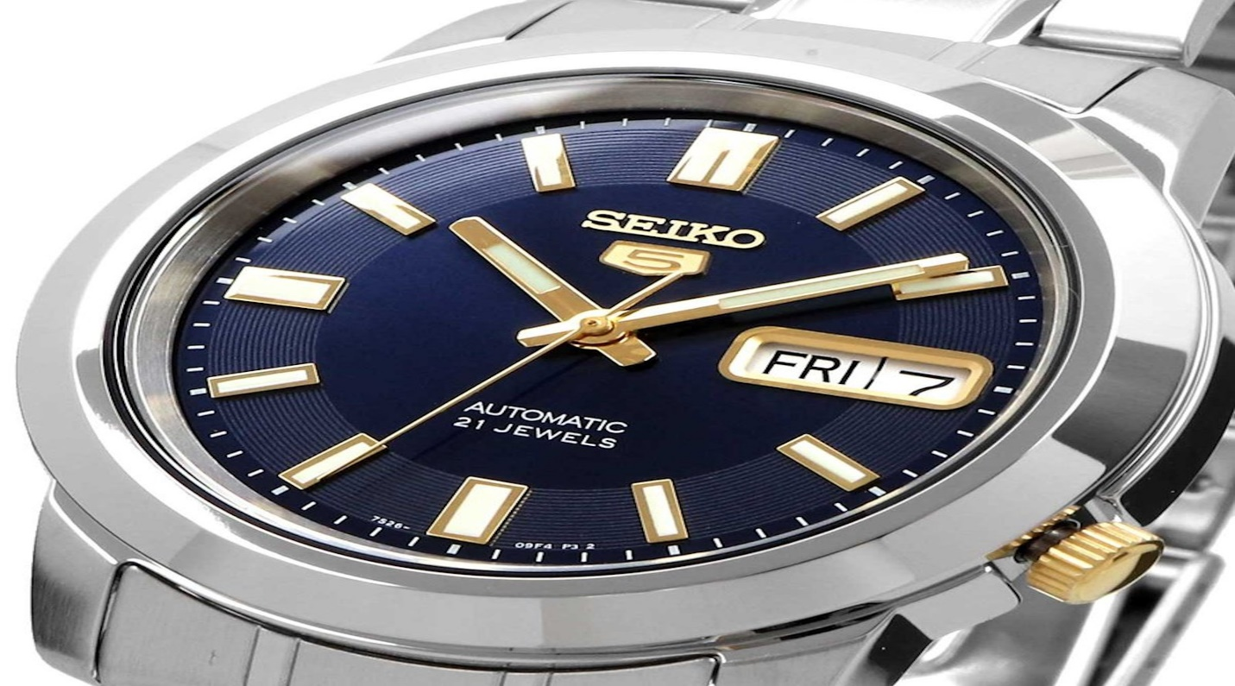Description: Seiko is a renowned Japanese watch brand known for its precision, innovation, and craftsmanship. Founded in 1881, Seiko has been a pioneer in watchmaking, introducing the world's first quartz watch and the famous **Spring Drive** and **Kinetic** movements. The brand offers a wide range of watches, from affordable everyday models to high-end luxury timepieces. Seiko watches are known for their **durability, accuracy, and elegant designs**, making them popular among both casual wearers and collectors. With options including **automatic, quartz, and solar-powered** watches, Seiko blends traditional watchmaking with modern technology, delivering reliability and style for every occasion.